|  |  |
| --- | --- |
| Stella Nova Logo | LOGO4 |
| Best Buy Canada Mobile | |
| |  | | --- | | **Transaction Search Feature Document** |   **Document Version: 1.2**  **Design Date: March 27, 2013** | |
| **Prepared By: Amy Lackas** | |
|  | |

**Table of Contents**

*1.**Feature Overview* 3

1.1 Feature Description 3

1.2 Assumptions 3

1.3 Parameters and System Settings 3

1.4 Interfaces 3

*2.**USE CASE: Search by Transaction* 3

2.1 Feature Flow 3

2.2 Precondition 3

2.3 Main Flow 4

2.4 Alternate Flows 4

2.5 Post Condition 4

2.6 Special Requirements 4

*3.**USE CASE: Search by Tender* 5

3.1 Feature Flow 5

3.2 Precondition 5

3.3 Main Flow 5

3.4 Alternate Flows 6

3.5 Post Condition 6

3.6 Special Requirements 6

*4.**USE CASE: Search by Customer* 7

4.1 Feature Flow 7

4.2 Precondition 7

4.3 Main Flow 7

4.4 Alternate Flows 8

4.5 Post Condition 8

4.6 Special Requirements 8

*5.**USE CASE: Retrieve Transaction* 8

5.1 Feature Flow 8

5.2 Precondition 8

5.3 Main Flow 9

5.4 Alternate Flows 9

5.5 Post Condition 9

5.6 Special Requirements 9

*6.**Supplemental Specifications* 9

6.1 Reprint Receipt 9

*7.**Screen Layouts* 10

7.1 Transaction Search by Transaction 10

7.2 Transaction Search by Tender 12

7.3 Transaction Search by Customer 15

*8.**Revision History* 17

*9.**Appendix* A*: Source Documentation* 17

9.1 Functional Requirements 17

*10.**Appendix* B*: Glossary* 17

*11.**Interface: Transaction Lookup* 18

11.1 Search by Tender 18

11.2 Search By Customer 18

11.3 Search By Transaction 18

# *Feature Overview*

## Feature Description

The Transaction Search functionality provides the ability to search for transactional information using various search criteria. Transaction Search is not available as a selectable feature within mPOS via the UI but is used by other features, such as Receipt Reprint.

## Assumptions

1. Transaction searches are completed against the customer’s corporate database via the Transaction Lookup Service. The system does not search against the current database.

## Parameters and System Settings

|  |  |  |
| --- | --- | --- |
| **Parameter Mnemonic** | **Description** | **Valid Values** |
| Maximum Search Matches | Determines the maximum amount of search results to be displayed for a given transaction search | 0 to 99 |

## Interfaces

|  |  |
| --- | --- |
| **Interface** | **Description** |
| Transaction Lookup Service | Searches for transactions against the Customer’s database. The search criteria can be 4-part transaction key, tender or customer details. |

# *USE CASE: Search by Transaction*

## Feature Flow



## Precondition

* The system initiates a search for a transaction based on transaction information.

## Main Flow

1. The system prompts the operator to enter the transaction information.
2. If the operator selects to search by tender, the use case ends and the system executes the Search By Tender use case.
3. If the operator selects to search by customer, the use case ends and the system executes the Search By Customer use case.
4. The operator enters the transaction information and accepts the entry.
5. The system validates the transaction information.
6. If the transaction information is invalid, the system displays a message, the operator acknowledges the message and the Main Flow restarts.
7. The system executes the Retrieve Transaction alternate flow.

## Alternate Flows

None

## Post Condition

* Transaction information is collected and the system calls external transaction lookups service to search for the transaction using the search criteria.

## Special Requirements

1. Validation is based on entering the minimum/maximum number of characters in the UI.
2. When using the scanner to enter the transaction key, scanning is an implied enter.
3. When performing a receipt search by Transaction, the data entry fields will be presented in the order in which they appear on a receipt allowing the focus to follow the same flow (when navigating between data fields using a hardware keyboard):  
   Store  
   Register  
   Transaction  
   Date  
   SKU

### Special Offline Requirements

No additional offline requirements as offline behaviors are explained in the use case or do not impact this feature.

### Data Input/Output

|  |  |  |
| --- | --- | --- |
| **Data Element** | **Description** | **Destination** |
| Transaction Search by Transaction Entry | Journal entry stating the Search by Transaction process is starting | * E-Journal |

# *USE CASE: Search by Tender*

## Feature Flow



## Precondition

* The system initiates a search for a transaction based on tender information.

## Main Flow

1. The system prompts the operator to enter the tender information.
2. If the operator selects to search by customer, the use case ends and the system executes the Search By Customer use case.
3. If the operator selects to search by transaction, the use case ends and the system executes the Search By Transaction use case.
4. If the operator manually enters the tender information, the Search by Manual Entry alternate flow is executed.
5. If the operator scans the tender information, the Search by Scan alternate flow is executed.
6. The operator swipes the card and accepts the entry.
7. If the swipe is unsuccessful, the system displays a message, the operator acknowledges the message and the Main Flow restarts.
8. The device reads the data on the magnetic stripe.
9. If the swipe is successful, the system validates the card ID.
10. If the card ID is invalid, the system displays a message, the operator acknowledges the message and the Main Flow restarts.
11. The system executes the Retrieve Transaction alternate flow.

## Alternate Flows

### Search by Manual Entry

1. The operator enters the card ID and accepts the entry.
2. The system determines if a Check Digit computation is required.
3. If a Check Digit computation is required, the Check Digit use case is executed.
4. If the system returns from the Check Digit use case with an invalid check digit, the system displays a message, the operator acknowledges the message and the Main Flow restarts.
5. The system executes the Retrieve Transaction alternate flow.

### Inquiry by Scan

1. If the scan is unsuccessful, the system restarts the Main Flow.
2. The device reads the card information from the bar code.
3. The system determines if a Check Digit computation is required.
4. If a Check Digit computation is required, the Check Digit use case is executed.
5. If the system returns from the Check Digit use case with an invalid check digit, the system displays a message, the operator acknowledges the message and the Main Flow restarts.
6. The system executes the Retrieve Transaction alternate flow.

## Post Condition

* Tender information is collected and the system calls external transaction lookups service to search for the transaction using the search criteria.

## Special Requirements

1. The Search by Tender screen is the first screen displayed when Reprint Receipt is selected from Transaction Modify menu.
2. Search Criteria include the following:
   1. Card Type – required selection
   2. Account Number – required entry/scan
   3. Date Range – required, maximum 6 month range
   4. Store - optional
3. The system allows different types of card types to be entered - Credit Card (CC), Debit Card (DC), Gift Card (GC). The codes associated with card type is passed to the external system to search for the transaction.
4. Card numbers, whether entered manually or swiped will not be displayed to the user in the data entry field. The numbers will be represented by asterisks.

### Special Offline Requirements

No additional offline requirements as offline behaviors are explained in the use case or do not impact this feature.

### Data Input/Output

|  |  |  |
| --- | --- | --- |
| **Data Element** | **Description** | **Destination** |
| Transaction Search by Tender Entry | Journal entry stating the Transaction Search by Tender process is starting | * E-Journal |

# *USE CASE: Search by Customer*

## Feature Flow

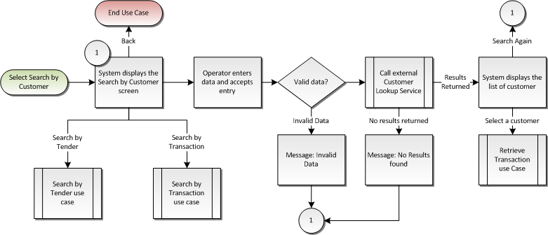

## Precondition

* The system initiates a search for a transaction based on customer information.

## Main Flow

1. The system prompts the operator to enter the customer information.
2. If the operator selects to search by tender, the use case ends and the system executes the Search By Tender use case.
3. If the operator selects to search by transaction, the use case ends and the system executes the Search By Transaction use case.
4. The operator enters the customer information and accepts the entry.
5. The system validates the customer information.
6. If the customer information is invalid, the system displays a message, the operator acknowledges the message and the Main Flow restarts.
7. The system searches for the customer information.
8. If no results are returned or no results are found because the system is offline or the search times out, the system displays a message; the operator acknowledges the message and the Main Flow is restarted.
9. If the search returns a single record, the flow continues where the system displays the customer details and prompts the operator to select an option.
10. If the search returns two or more results, the system displays the search results and prompts the operator to select a customer or select an option.
11. If the operator selects to search again, the Main Flow is restarted.
12. The operator selects a customer.
13. The system executes the Retrieve Transaction alternate flow.

## Alternate Flows

None

## Post Condition

* Customer information is collected and the system calls external transaction lookups service to search for the transaction using the search criteria.

## Special Requirements

1. Search Criteria include the following:
   1. Phone Number – the system requires either Phone Number or Last Name or both to be entered
   2. First Name – optional
   3. Last Name - the system requires either Phone Number or Last Name or both to be entered
   4. Date Range – required, maximum 6 month range
2. Validation is based on entering the minimum/maximum number of characters in the UI.

### Special Offline Requirements

No additional offline requirements as offline behaviors are explained in the use case or do not impact this feature.

### Data Input/Output

|  |  |  |
| --- | --- | --- |
| **Data Element** | **Description** | **Destination** |
| Transaction Search by Transaction Entry | Journal entry stating the Search by Transaction process is starting | * E-Journal |

# *USE CASE: Retrieve Transaction*

## Feature Flow



## Precondition

* The system receives search criteria to retrieve a transaction.

## Main Flow

1. The system calls external transaction lookup service to search for transactions meeting the search criteria entered.
2. If a connection error or timeout occurs, the system displays a message, the operator acknowledges the message, the use case ends and the system returns to the calling use case.
3. If no transaction is found, the system displays a message, the operator acknowledges the message, the use case ends and the system returns to the calling use case.
4. If more than one transaction is found but less than the Maximum Search Matches parameter, the system displays a list of matching transactions and prompts the operator to select a transaction.
5. The system retrieves the transaction.
6. If the calling use case is Return without Receipt, the use case ends and returns to the Return with Receipt use case where the system prompts the operator to enter the item(s) for return.
7. The use case ends and returns to the calling use case.

## Alternate Flows

None

## Post Condition

* A transaction is retrieved.

## Special Requirements

1. Transactions are displayed in chronological order, newest to oldest.

### Special Offline Requirements

No additional offline requirements as offline behaviors are explained in the use case or do not impact this feature.

### Data Input/Output

|  |  |  |
| --- | --- | --- |
| **Data Element** | **Description** | **Destination** |
| Search Criteria | Entered search criteria | * External Transaction Lookup Service |
| Transaction Search Exit | Journal entry stating the Transaction Search process is over | * E-Journal |

# *Supplemental Specifications*

## Reprint Receipt

The Transaction Search Use Cases are executed from the Reprint Receipt use cases.

# *Screen Layouts*

## Transaction Search by Transaction

This screen is displayed when the operator selects to search for a transaction using the transaction key. The operator is prompted to enter a specific transaction key. When using the scanner to enter the transaction key, scanning is an implied enter.

### Mockup

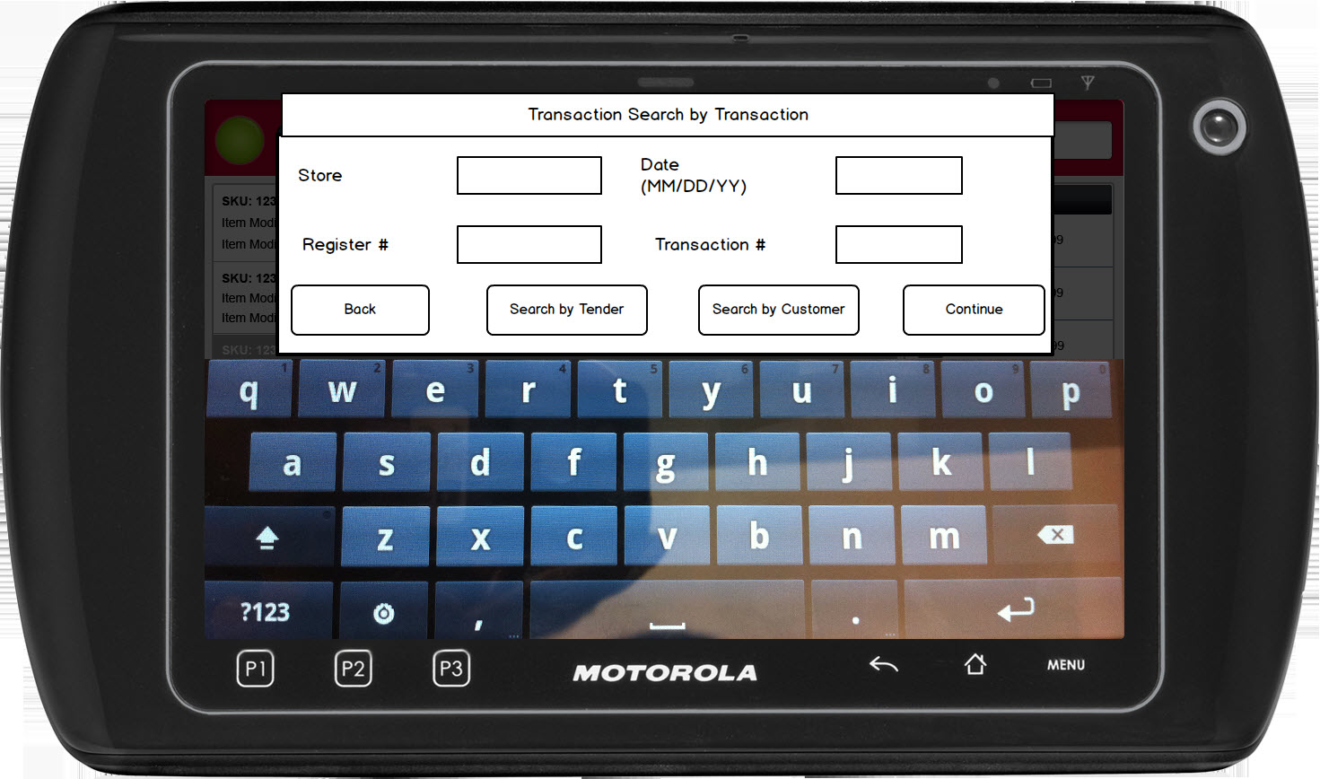

Figure 1: Transaction Search by Transaction

### Instruction Text

|  |
| --- |
| **Instructions** |
| None |

### Navigation/Menu Key

|  |  |  |  |
| --- | --- | --- | --- |
| **Label Text** | **State** | **Next Screen** | **Notes** |
| Back | Enabled | Previous screen | None |
| Search by Tender | Enabled | Transaction Search by Tender | None |
| Search by Customer | Enabled | Transaction Search by Customer | None |
| Continue | Enabled | * Connection Error: Connection Error * Invalid Data: Invalid Data Notice * No Transactions Found: No Transactions Found * Valid Data: Transaction List – Reprint Receipt | * Enabled upon data entry * Scanning is an implied enter |

### Data/Input Field

|  |  |  |  |  |  |  |
| --- | --- | --- | --- | --- | --- | --- |
| **Label/Placeholder Text** | **Editable** | **Req’d?** | **Data Type** | **Min**  **Length** | **Max**  **Length** | **Notes** |
| Store # | Yes | Yes | Numeric | 1 | 4 | None |
| Device # | Yes | Yes | Numeric | 1 | 3 | None |
| Tran # | Yes | Yes | Numeric | 1 | 4 | Same as a Transaction ID |
| Date | Yes | Yes | Date | 1 | 8 | None |

### Reason Code

|  |  |  |
| --- | --- | --- |
| **Reason Code** | **Valid Values** | **Default Value** |
| None |  |  |

### Connection Error

|  |  |
| --- | --- |
| **Size** | Size of message box (Please see UI Guidelines for size descriptions) |
| **Title** | Connection Error |
| **Description** | This message is displayed when the system is unable to retrieve suspended transaction(s) due to a connection error or timeout. Upon acknowledging the message, the system restarts the Main Flow |
| **Message Text** | Unable to search for suspended transactions at this time. |
| **Prompt Text** | Select OK to continue. |
| **Button(s)** | OK |
| **Notes** | Configurable message |

### Invalid Data Notice

|  |  |
| --- | --- |
| **Size** | Size of message box (Please see UI Guidelines for size descriptions) |
| **Title** | Invalid Data Notice |
| **Description** | This message informs the operator that the data entered in the required fields is invalid (e.g. incorrect format, missing). The <ARG> described in the Message is replaced with the name of the data field that contains the invalid data. If there are multiple data fields with invalid data, the system only displays the name of the first data field with invalid data. Upon acknowledging the message, the system returns to the previous screen. |
| **Message Text** | The following field has invalid data: <ARG>. |
| **Prompt Text** | Select OK to correct the invalid data. |
| **Button(s)** | OK |
| **Notes** | This is a generic message to be reused when required data is incorrect or missing. |

### No Transaction Found

|  |  |
| --- | --- |
| **Size** | Size of message box (Please see UI Guidelines for size descriptions) |
| **Title** | No Transaction Found |
| **Description** | This message appears when the operator searches for a transaction and no transaction is found. Upon acknowledging the message, the operator is returned to the previous screen. |
| **Message Text** | No transaction was found matching the search criteria. |
| **Prompt Text** | Select OK to search again. |
| **Button(s)** | OK |
| **Notes** | Configurable message |

## Transaction Search by Tender

This screen is displayed when the operator selects to search for a transaction using tender information. The operator is prompted to enter tender card (credit card, debit card or gift card) information.

### Mockup

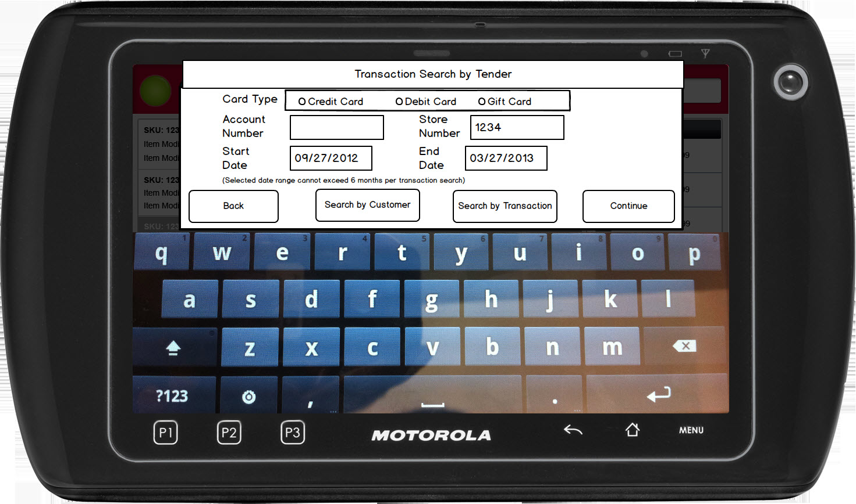

Figure 2: Transaction Search by Tender

### Instruction Text

|  |
| --- |
| **Instructions** |
| None |

### Navigation/Menu Key

|  |  |  |  |
| --- | --- | --- | --- |
| **Label Text** | **State** | **Next Screen** | **Notes** |
| Back | Enabled | Previous screen | None |
| Search by Transaction | Enabled | Transaction Search by Transaction | None |
| Search by Customer | Enabled | Transaction Search by Customer | None |
| Continue | Enabled | * Connection Error: Connection Error * Invalid Data: Invalid Data Notice * No Transactions Found: No Transactions Found * Valid Data: Transaction List – Reprint Receipt | Enabled upon data entry |

### Data/Input Field

|  |  |  |  |  |  |  |
| --- | --- | --- | --- | --- | --- | --- |
| **Label/Placeholder Text** | **Editable** | **Req’d?** | **Data Type** | **Min**  **Length** | **Max**  **Length** | **Notes** |
| Card Type | Yes | Yes | Selection | N/A | N/A | One selection is required. No default selection made upon entry to the screen. |
| Account Number | Yes | Yes | Numeric | 16 | 24 | Scanning is an implied enter, and will advance to the next field.  Data when entered is masked on the screen, displaying the last 4 digits with ‘*’ -- *****1234. |
| Store | Yes | No | Numeric | 0 | 4 | One store number may be entered.  The current store number is pre-populated in the field. |
| Date Range | Yes | Yes | Date | 10 | 10 | The default start date is 6 months prior to todays date, the default end date is todays date.  The system allows any date range as long as the total time between the start and end dates is within 6 months.  Format of the Date is MM/DD/YYYY |

### Reason Code

|  |  |  |
| --- | --- | --- |
| **Reason Code** | **Valid Values** | **Default Value** |
| Card Type | * Credit Card * Debit Card * Gift Card | No default value |

### Connection Error

|  |  |
| --- | --- |
| **Size** | Size of message box (Please see UI Guidelines for size descriptions) |
| **Title** | Connection Error |
| **Description** | This message is displayed when the system is unable to retrieve suspended transaction(s) due to a connection error or timeout. Upon acknowledging the message, the system restarts the Main Flow |
| **Message Text** | Unable to search for suspended transactions at this time. |
| **Prompt Text** | Select OK to continue. |
| **Button(s)** | OK |
| **Notes** | Configurable message |

### Invalid Data Notice

|  |  |
| --- | --- |
| **Size** | Size of message box (Please see UI Guidelines for size descriptions) |
| **Title** | Invalid Data Notice |
| **Description** | This message informs the operator that the data entered in the required fields is invalid (e.g. incorrect format, missing). The <ARG> described in the Message is replaced with the name of the data field that contains the invalid data. If there are multiple data fields with invalid data, the system only displays the name of the first data field with invalid data. Upon acknowledging the message, the system returns to the previous screen. |
| **Message Text** | The following field has invalid data: <ARG>. |
| **Prompt Text** | Select OK to correct the invalid data. |
| **Button(s)** | OK |
| **Notes** | This is a generic message to be reused when required data is incorrect or missing. |

### No Transaction Found

|  |  |
| --- | --- |
| **Size** | Size of message box (Please see UI Guidelines for size descriptions) |
| **Title** | No Transaction Found |
| **Description** | This message appears when the operator searches for a transaction and no transaction is found. Upon acknowledging the message, the operator is returned to the previous screen. |
| **Message Text** | No transaction was found matching the search criteria. |
| **Prompt Text** | Select OK to search again. |
| **Button(s)** | OK |
| **Notes** | Configurable message |

## Transaction Search by Customer

This screen is displayed when the operator selects to search for a transaction using customer information. The operator is prompted to enter customer information.

Note: The search results screen is the same as the screens used in customer capture.

### Mockup

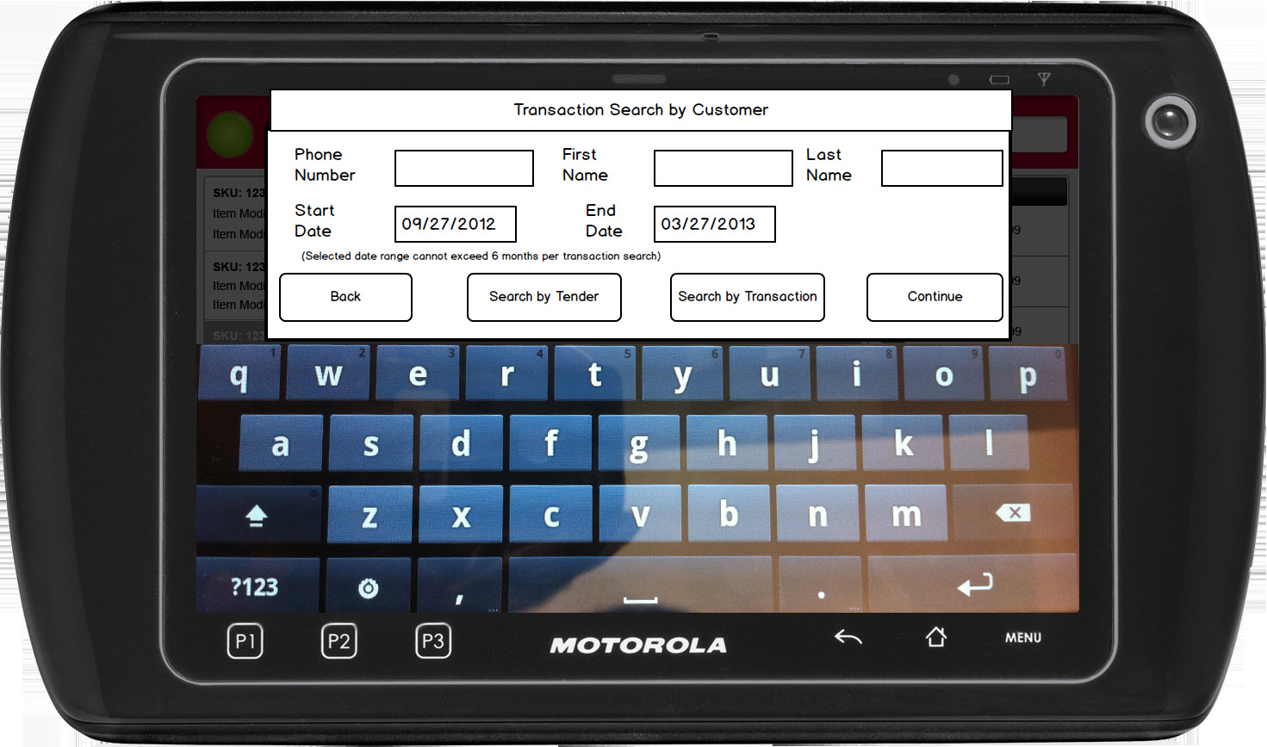

Figure 3: Transaction Search by Customer

### Instruction Text

|  |
| --- |
| **Instructions** |
| None |

### Navigation/Menu Key

|  |  |  |  |
| --- | --- | --- | --- |
| **Label Text** | **State** | **Next Screen** | **Notes** |
| Back | Enabled | Previous screen | None |
| Search by Tender | Enabled | Transaction Search by Tender | None |
| Search by Transaction | Enabled | Transaction Search by Transaction | None |
| Continue | Enabled | * Connection Error: Connection Error * Invalid Data: Invalid Data Notice * No Transactions Found: No Transactions Found * Valid Data: Customer Results List | Enabled upon data entry |

### Data/Input Field

|  |  |  |  |  |  |  |
| --- | --- | --- | --- | --- | --- | --- |
| **Label/Placeholder Text** | **Editable** | **Req’d?** | **Data Type** | **Min**  **Length** | **Max**  **Length** | **Notes** |
| Phone Number | Yes | See Notes | Numeric | 10 | 10 | At least Phone Number or Last Name must be entered. |
| First Name | Yes | See Notes | Alphanumeric | 1 | 25 | At least Phone Number or Last Name must be entered. |
| Last Name | Yes | See Notes | Alphamueric | 1 | 25 | At least Phone Number or Last Name must be entered. |
| Date Range | Yes | Yes | Date |  |  | The default start date is 6 months prior to todays date, the default end date is todays date.  The system allows any date range as long as the total time between the start and end dates is within 6 months.  Format of the Date is MM/DD/YYYY |

### Reason Code

|  |  |  |
| --- | --- | --- |
| **Reason Code** | **Valid Values** | **Default Value** |
| None |  |  |

### Connection Error

|  |  |
| --- | --- |
| **Size** | Size of message box (Please see UI Guidelines for size descriptions) |
| **Title** | Connection Error |
| **Description** | This message is displayed when the system is unable to retrieve suspended transaction(s) due to a connection error or timeout. Upon acknowledging the message, the system restarts the Main Flow |
| **Message Text** | Unable to search for suspended transactions at this time. |
| **Prompt Text** | Select OK to continue. |
| **Button(s)** | OK |
| **Notes** | Configurable message |

### Invalid Data Notice

|  |  |
| --- | --- |
| **Size** | Size of message box (Please see UI Guidelines for size descriptions) |
| **Title** | Invalid Data Notice |
| **Description** | This message informs the operator that the data entered in the required fields is invalid (e.g. incorrect format, missing). The <ARG> described in the Message is replaced with the name of the data field that contains the invalid data. If there are multiple data fields with invalid data, the system only displays the name of the first data field with invalid data. Upon acknowledging the message, the system returns to the previous screen. |
| **Message Text** | The following field has invalid data: <ARG>. |
| **Prompt Text** | Select OK to correct the invalid data. |
| **Button(s)** | OK |
| **Notes** | This is a generic message to be reused when required data is incorrect or missing. |

### No Transaction Found

|  |  |
| --- | --- |
| **Size** | Size of message box (Please see UI Guidelines for size descriptions) |
| **Title** | No Transaction Found |
| **Description** | This message appears when the operator searches for a transaction and no transaction is found. Upon acknowledging the message, the operator is returned to the previous screen. |
| **Message Text** | No transaction was found matching the search criteria. |
| **Prompt Text** | Select OK to search again. |
| **Button(s)** | OK |
| **Notes** | Configurable message |

# *Revision History*

|  |  |  |  |
| --- | --- | --- | --- |
| **Reviser** | **Revision** | **Date** | **Version** |
| Amy Lackas | Created initial version | 03/27/2013 | 1.0 |
| Amy Lackas | Updates after internal review | 04/05/2013 | 1.1 |
| Amy Lackas | Corrected Search by Customer flow | 06/04/2013 | 1.2 |
| Amy Byers | Added clarification that account numbers are masked on the screen and that transaction entry fields are in order as on receipt. | 9/10/2014 | 1.3 |

# *Appendix : Source Documentation*

* Requirement Specification - XPOS

## Functional Requirements

| **ID** | **Category** | **Sub-Category** | **Description** | **Section(s)** |
| --- | --- | --- | --- | --- |
| 2.25.2 | Functions | Reprint Receipt | Card numbers, whether entered manually or swiped will not be displayed to the user in the data entry field. The numbers will be represented by asterisks. | * 2.6 Special Requirements |
| 2.27 | Functions | Reprint Receipt | When performing a receipt search by Transaction, the data entry fields will be presented in the order in which they appear on a receipt allowing the focus to follow the same flow (when navigating between data fields using a hardware keyboard): Store Register Transaction Date SKU | * 3.6 Special Requirements |

# *Appendix : Glossary*

|  |  |
| --- | --- |
| **Term** | **Definition** |
| None |  |

# *Interface: Transaction Lookup*

## Search by Tender

The following changes are being added to the interface:

* LocationNumber element is added to searchParameter. This will represent the entered store number on the search by tender screen.
* searchTypeToPerform – searchByAccount when searching by tender.
* The accountNumber field will send the following
  + For accountCategory of CC (Card Type = Credit Card)– first 6 digits and last 4 digits of the entered account number, it will be a 10 digit number that is sent.
  + For accountCategory of DC (Card Type = Debit Card) – first 6 digits and last 4 digits of the entered account number, it will be a 10 digit number that is sent.
  + For accountCategory of GC (Card Type = Gift Card)– full entered account number.

<searchTransactionsRequest>

<metadata>

<applicationID>K15ICE</applicationID> <!-- value used by POS? -->

<programID>CRM</programID> <!-- value used by POS? -->

<userID>BEST-AA8E5941ED</userID> <!-- Store User ID-->

<timeStamp>2007-1-1 00:00:00</timeStamp>

</metadata>

<searchConfig>

<maxRows>100</maxRows> <!-- DB Parameter value for MAX_TRANS_DISPLAY -->

<searchTimeLimitMS>3000</searchTimeLimitMS> <!-- DB Parameter value for TIMEOUT -->

<searchTypeToPerform/> <!-- values: searchByAccount, searchByGlobalContractId, searchByCustomerId,

searchByWebORder -->

<discardResult/> <!-- values: true – give error when maxRows reached, false – don’t give error when max results reached-->

</searchConfig>

<searchParameter>

<transactionSource/> <!-- **OPTIONAL.** values: **POS,** ORDER -->

<startDate /> <!-- Start date from search critera screen -->

<endDate /> <!-- End date from search critera screen -->

<sku /> <!—**OPTIONAL**. SKU from search critera screen -->

<locationNumber /> <!—**OPTIONAL**. Store Number from search criteria screen -->

<account>

<accountCategory/> <!-- values: CC – Credit card , DB – Debit card, GC – Gift Card

RWZC – Reward Zone Certificate -->

<accountNumber /> <!-- ID from search critera screen or First 6 digits and Last 4 digits of entered

Account number for accountCateogry CC or DC or full number of Gift Card

for accountCateogry GC. -->

</account>

</searchParameter>

</searchTransactionsRequest>

## Search By Customer

* searchTypeToPerform – searchByCustomerId when searching by Customer.
* Not sure if a call to CLUP is made first then make a request to TLUP

## Search By Transaction

* searchTypeToPerform – searchByGlobalContractId when searching by Transaction 4-part key.
* searchParameter/transactionKey/TransactionKey – Transaction 4-part key in the format
* searchParameter/transactionKey/transactionSourceSystemID